Pet Selling App

ppt2 Workshop #02

Flutter Developer Bootcamp

# **Purpose**

This workshop demonstrates how to create a pet selling screen with pet details.

# **Problem**

You're tasked with adding two new features to a Pet Selling App:

1. Gender Selection: Implement a radio button system to enable sellers to select the gender of the pet they are listing for sale. Options should include "Male" and "Female".
2. Description Textfield: Integrate a textfield where sellers can input a description of the pet they are selling.

# **How to Solve**

1. Checkout the workshop from Git Repo:

git clone -b <user-branch> <repo-URL>

2. Open the root folder inside VS Code

3. To build the app click the run option in the main method { }

4. Create a radio button and text field to solve this problem

**You Will Achieve**

At the end of the workshop, you'll learn how to make forms in apps using Flutter. The code teaches you about different parts of the user interface, like text boxes, dropdown menus, and checkboxes. It also shows you how to arrange things on the screen and make them look nice. You'll see how users can interact with the app, like typing or clicking on things. Even though it doesn't show everything, it still helps you understand why some things are important. Overall, it's a good way to learn the basics of making apps with Flutter.

# **Screenshots**

## **Before implementation (without Radio Button & TextField)**

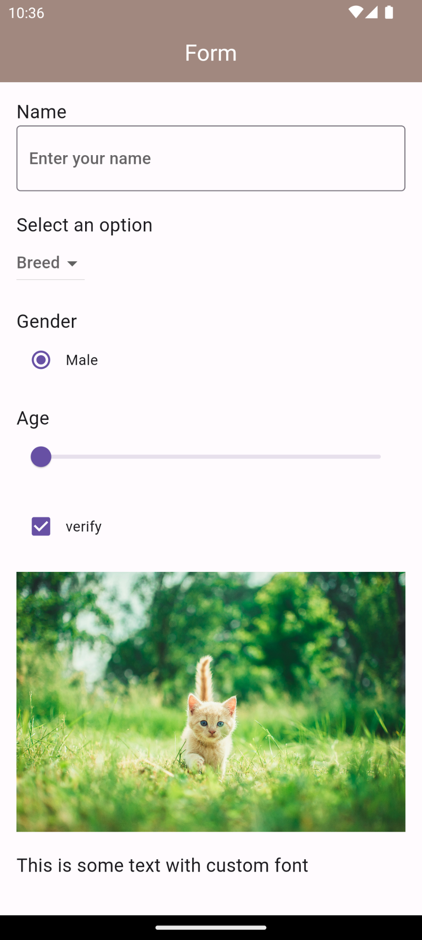

## **After implementation (With Radio Button & TextField)**

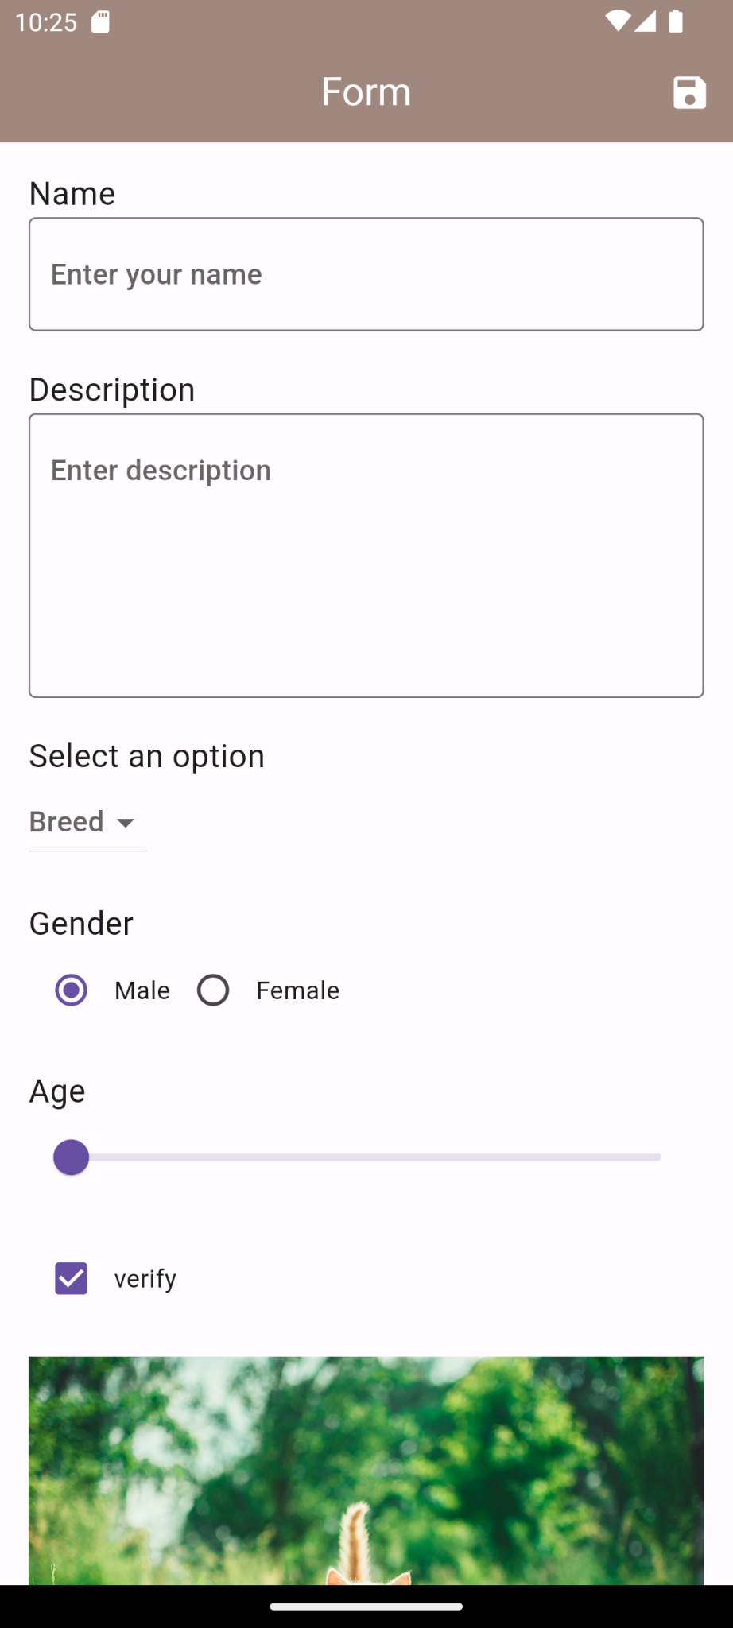 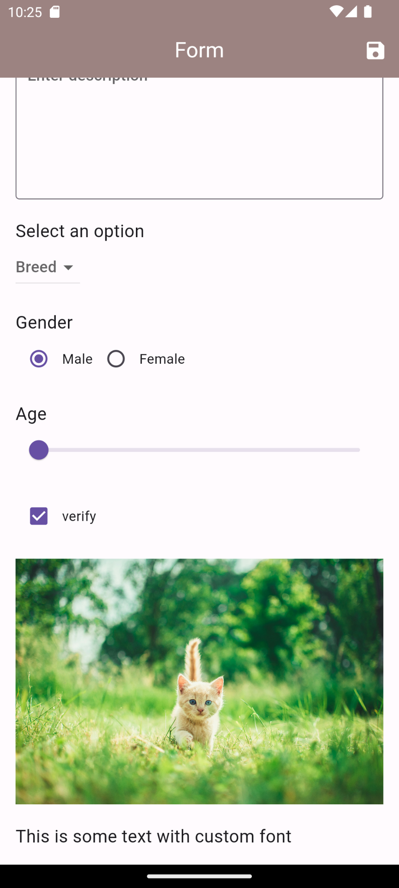

# **How to submit your workshop**

Push your project back to the same git branch using command:

<command name>

# **Happy Coding!**